Merrill Rudd

FSH 507 Spatio-temporal modeling

Homework 3 – Temporal models

April 20, 2016

**Simulation experiment**

I used a dynamic linear model to simulate 100 replicates of observed data three levels of autocorrelation crossed with three levels of measurement error, keeping process error fixed between scenarios. The estimation procedure matched the dynamic linear model used in the data generation. This simulation study tested the ability to estimate the autocorrelation, process error, and observation error in all scenarios of true autocorrelation and observation error.

I found that estimates of autocorrelation were unbiased regardless of the level of autocorrelation or true observation error. However, the precision of the estimates varied by level of observation error. With relatively low observation error, the precision was relatively high, but with relatively high observation error, the precision was lower. There were biases in estimates of process and observation error across all levels of autocorrelation. When there was no autocorrelation, estimates of process and observation error were unbiased only when the true level of observation error was high. When observation error was high, all parameter estimates were similarly imprecise. An interesting finding is that the estimates of autocorrelation were unbiased for all scenarios, regardless of whether the process and observation error estimates were biased.

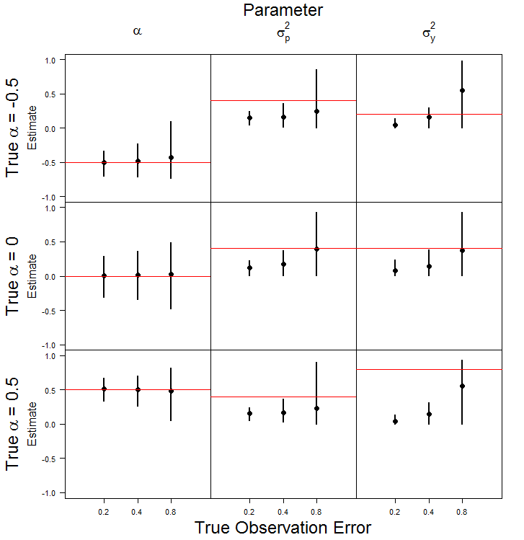

Figure 1. Mean estimates of the three parameters for the dynamic linear model from 100 replicates of simulated data for each of three levels of observation error and three levels of true autocorrelation. Line segments represent the 2.5 and 97.5 percentile from the 100 replicates of simulated data.

**Gompertz model**

* Density-dependence – stable or unstable equilibrium point
* Wikipedia a power series – convergent if beta is between -1 and 1
  + Summation of a power series is equal to alpha/(1-beta) 🡪 that’s how you get the equilibrium value
* Confidence intervals computed in logspace often a better summary than those computed in regular space
  + One of the two parameters will go to zero

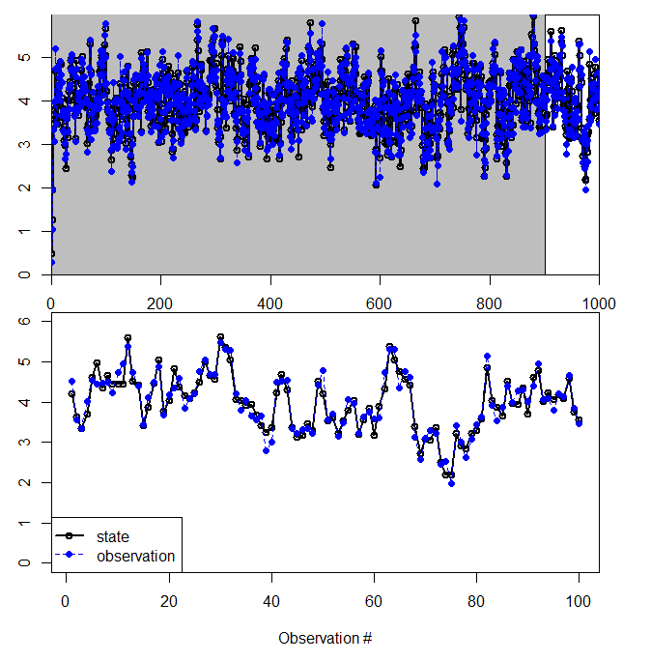

Figure 2. Plot of time series of the states (black) and observations (blue) generated by the Gompertz model. The top panel is 1000 observations used to visually confirm that the Gompertz model reached equilibrium. The bottom panel is the last 100 observations chosen as generated data once the model had reached equilibrium.

Table 2. Gompertz model parameter estimates and their associated standard deviations.

|  |  |  |
| --- | --- | --- |
| Parameter | Mean | Standard Deviation |
| α | 1.340 | 0.307 |
| β | 0.663 | 0.075 |
| σp | 0.544 | 0.039 |
| σy | 0.006 | 0.132 |